**CHARACTERIZING AND PREDICTING EARLY REVIEWERS FOR EFFECTIVE PRODUCT MARKETING ON E-COMMERCE WEBSITES**

**ABSTRACT:**

Online reviews have become an important source of information for users before making an informed purchase decision. Early reviews of a product tend to have a high impact on the subsequent product sales. In this paper, we take the initiative to study the behavior characteristics of early reviewers through their posted reviews on two real-world large e-commerce platforms, i.e., Amazon and Yelp. In specific, we divide product lifetime into three consecutive stages, namely early, majority and laggards. A user who has posted a review in the early stage is considered as an early reviewer. We quantitatively characterize early reviewers based on their rating behaviors, the helpfulness scores received from others and the correlation of their reviews with product popularity. We have found that (1) an early reviewer tends to assign a higher average rating score; and (2) an early reviewer tends to post more helpful reviews. Our analysis of product reviews also indicates that early reviewers’ ratings and their received helpfulness scores are likely to influence product popularity. By viewing review posting process as a multiplayer competition game, we propose a novel margin-based embedding model for early reviewer prediction. Extensive experiments on two different e-commerce datasets have shown that our proposed approach outperforms a number of competitive baselines.

**ARCHITECTURE:**

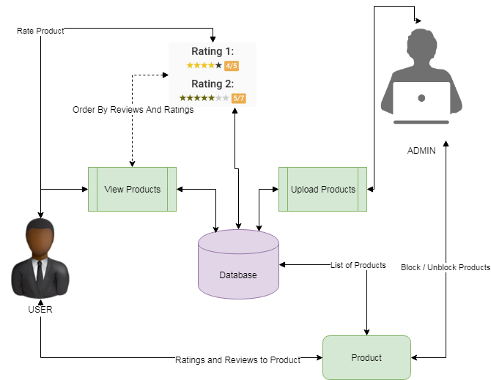

**EXISTING SYSTEM:**

Previous studies have highly emphasized the phenomenon that individuals are strongly influenced by the decisions of others, which can be explained by herd behavior. The influence of early reviews on subsequent purchase can be understood as a special case of herding effect. Early reviews contain important product evaluations from previous adopters, which are valuable reference resources for subsequent purchase decisions. As shown in, when consumers use the product evaluations of others to estimate product quality on the Internet, herd behavior occurs in the online shopping process. Different from existing studies on herd behavior, we focus on quantitatively analyzing the overall characteristics of early reviewers using large-scale real-world datasets. In addition, we formalize the early reviewer prediction task as a competition problem and propose a novel embedding based ranking approach to this task. To our knowledge, the task of early reviewer prediction itself has received very little attention in the literature. Our contributions are summarized as follows:

We present a first study to characterize early reviewers on an e-commerce website using two real-world large datasets. We quantitatively analyze the characteristics of early reviewers and their impact on product popularity. Our empirical analysis provides support to a series of theoretical conclusions from the sociology and economics. We view review posting process as a multiplayer competition game and develop an embedding-based ranking model for the prediction of early reviewers. Our model can deal with the cold-start problem by incorporating side information of products. Extensive experiments on two real-world large datasets, i.e., Amazon and Yelp have demonstrated the effectiveness of our approach for the prediction of early reviewers.

**PROPOSED SYSTEM:**

To predict early reviewers, we propose a novel approach by viewing review posting process as a multiplayer competition game. Only the most competitive users can become the early reviewer’s w.r.t. to a product. The competition process can be further decomposed into multiple pairwise comparisons between two players. In a two-player competition, the winner will beat the loser with an earlier timestamp. Inspired by the recent progress in distributed representation learning, we propose to use a margin-based embedding model by first mapping both users and products into the same embedding space, and then determining the order of a pair of users given a product based on their respective distance to the product representation.

**ALGORITHM:**

**Naïve Bayes Algorithm:**

In machine learning, naive Bayes classifiers are a family of simple "probabilistic classifiers" based on applying Bayes' theorem with strong (naive) independence assumptions between the features. Naive Bayes has been studied extensively since the 1950s. It was introduced under a different name into the text retrieval community in the early 1960s, and remains a popular (baseline) method for text categorization, the problem of judging documents as belonging to one category or the other (such as spam or legitimate, sports or politics, etc.) with word frequencies as the features. With appropriate pre-processing, it is competitive in this domain with more advanced methods including support vector machines. It also finds application in automatic medical diagnosis.[3] Naive Bayes classifiers are highly scalable, requiring a number of parameters linear in the number of variables (features/predictors) in a learning problem. Maximum-likelihood training can be done by evaluating a closed-form expression, 718 which takes linear time, rather than by expensive iterative approximation as used for many other types of classifiers. In the statistics and computer science literature, naive Bayes models are known under a variety of names, including simple Bayes and independence Bayes. All these names reference the use of Bayes' theorem in the classifier's decision rule, but naive Bayes is not (necessarily) a Bayesian method.

**MODULES:**

1. **UPLOAD PRODUCTS**

Uploading the products is done by admin. Authorized person is uploading the new arrivals to system that are listed to users. Product can be uploaded with its attributes such as brand, color, and all other details of warranty. The uploaded products are able to block or unblock by users.

1. **PRODUCT REVIEW BASED ORDER**

The suggestion to user’s view of products is listed based on the review by user and rating to particular item. Naïve bayes algorithm is used in this project to develop the whether the sentiment of given review is positive or negative. Based on the output of algorithm suggestion to users is given. The algorithm is applied and lists the products in user side based on the positive and negative.

1. **RATINGS AND REVIEWS**

Ratings and reviews are main concept of the project in order to find effective product marketing. The main aim of the project is to get the user reviews based on how they purchased or whether they purchased or not. The major find out of the project is when they give the ratings and how effective it is. And this will helpful for the users who are willing to buy the same kind of product.

1. **DATA ANALYSIS**

The main part of the project is to analysis the ratings and reviews that are given by the user. The products can be analysis based on the numbers which are given by user. The user data analysis of the data can be done by charts format. The graphs may vary like pie chart, bar chart or some other charts.

**FUTURE WORK:**

In our current work, the review content is not considered. In the future, we will explore effective ways in incorporating review content into our early reviewer prediction model. Also, we have not studied the communication channel and social network structure in diffusion of innovations partly due to the difficulty in obtaining the relevant information from our review data. We will look into other sources of data such as Flixster in which social networks can be extracted and carry out more insightful analysis. Currently, we focus on the analysis and prediction of early reviewers, while there remains an important issue to address, i.e., how to improve product marketing with the identified early reviewers. We will investigate this task with real e-commerce cases in collaboration with e-commerce companies in the future.

**CONCLUSION:**

In this paper, we have studied the novel task of early reviewer characterization and prediction on two real-world online review datasets. Our empirical analysis strengthens a series of theoretical conclusions from sociology and economics. We found that (1) an early reviewer tends to assign a higher average rating score; and (2) an early reviewer tends to post more helpful reviews. Our experiments also indicate that early reviewers’ ratings and their received helpfulness scores are likely to influence product popularity at a later stage. We have adopted a competition-based viewpoint to model the review posting process, and developed a margin based embedding ranking model (MERM) for predicting early reviewers in a cold-start setting.